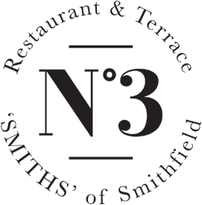

Scottish steak tartare, charred peppers, girolles, Copper Maran egg yolk, toasted sourdough 12
Orkney scallops, heritage tomatoes, Oxsprings air dried ham, green olive, basil 15
Torched Cornish mackerel, smoked eel, pickled kohlrabi, horseradish, beetroot vinaigrette 11
Slow-cooked Hampshire lamb scrumpet, anchovy, samphire, salad cream 10.5

Slow-cooked duck egg, charred onion, truffle, brioche (v) 10

28 day dry aged Scotch sirloin 21
Slow roasted shoulder of Hampshire lamb 19
Cotswolds free range chicken 17
All served with duck fat roasties, seasonal roasted vegetables, cauliflower cheese,
gravy and Yorkshire pudding.

700g dry aged Scotch Côte de Boeuf 75
700g dry aged Chateaubriand 80
All served with duck fat roasties, seasonal roasted vegetables, cauliflower cheese,
gravy and Yorkshire pudding.
For 2-4 people, depending on appetite.

Roasted skate wing, Dorset ‘Nduja, mussel, cider, seashore vegetables 28
Scottish rare breed cottage pie, pulled brisket, Montgomery Cheddar, BBQ glazed haricot beans 18
Salt baked celeriac, red wine glazed salsify, pear, goats curd, hazelnut vinaigrette, dandelion 18

Triple cooked chips 4.5
Crushed carrot and swede, pumpkin seeds 4.5
Grilled hispi cabbage, anchovy and capers 4.5

Purple sprouting broccoli, marmite butter 5
Steamed spinach, olive oil, preserved lemon 5

A discretionary service charge of 12.5% will be added to your bill. Before you order your food and drink, please inform a member of staff if you have a food allergy or intolerance. All prices are inclusive of VAT.

